Experiment List

Subject: Data Structures (DJS23DPC251L) | Academic Year: 2025-26
Semester: IV

Experiment No. | Title | CO
 | Analyze and implement Selection Sort and Quick Sort algorithms to evaluate their performance. | CO3
 | Describe and demonstrate the structure and operations of a Singly Linked List. | CO1
 | Apply stack-based technique to convert an infix expression into postfix form. | CO2
 | Illustrate the working of a Linear Queue and its basic operations. | CO1
 | Apply binary tree traversal techniques (Inorder, Preorder, Postorder) for data processing. | CO2
 | Analyze and implement Linear Search, Binary Search, and Bubble Sort algorithms. | CO3
 | Apply hashing techniques to store and retrieve data efficiently. | CO2
 | Solve the problem of removing duplicates from Sorted List on the LeetCode platform. | CO2
 | Apply appropriate data structures to evaluate a Reverse Polish Notation expression on the LeetCode platform. | CO2
 | Solve the Circular Game problem using queue data structure on the LeetCode platform. | CO2

EXPERIMENT NO. 1

SELECTION AND QUICK SORT

AIM: Implementation of Selection and Quick Sort.

THEORY:

Selection Sort
Selection Sort is a comparison-based sorting algorithm. It sorts an array by repeatedly selecting the smallest (or largest) element from the unsorted portion and swapping it with the first unsorted element. This process continues until the entire array is sorted.
- First we find the smallest element and swap it with the first element. This way we get the smallest element at its correct position.
- Then we find the smallest among remaining elements (or second smallest) and swap it with the second element.
- We keep doing this until we get all elements moved to correct position.

Here’s a basic overview of how the Selection Sort works.
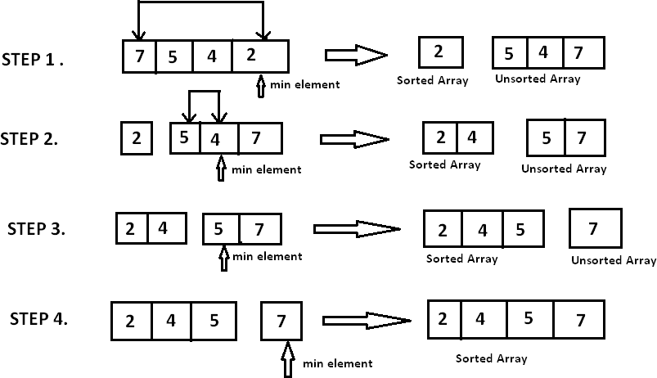

Quick Sort
Quick Sort works on the principle of divide and conquer, breaking down the problem into smaller sub-problems.
There are mainly three steps in the algorithm:
- Choose a Pivot: Select an element from the array as the pivot. The choice of pivot can vary (e.g., first element, last element, random element, or median).
- Partition the Array: Rearrange the array around the pivot. After partitioning, all elements smaller than the pivot will be on its left, and all elements greater than the pivot will be on its right. The pivot is then in its correct position, and we obtain the index of the pivot.
- Recursively Call: Recursively apply the same process to the two partitioned sub- arrays (left and right of the pivot).
- Base Case: The recursion stops when there is only one element left in the sub- array, as a single element is already sorted.
Here’s a basic overview of how the Quick Sort algorithm works.

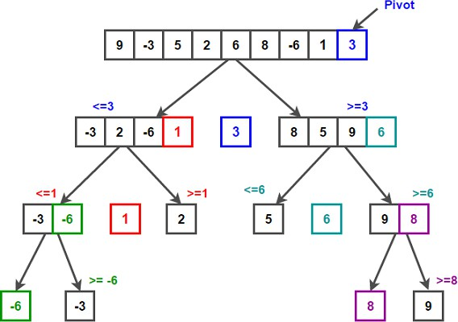

ALGORITHM:
Selection Sort
- Start.
- Define an array ‘A’ of size ‘n’.
- Read array elements from the user.
- Define first element of the array as ‘min’ i.e. min=A[0].
- For i←0 to n-1
  - min←A[i]
  - loc←i //loc variable keeps the track of minimum element
  - for j←i+1 to n-1
    - if (A[j]<min) then
      - min←A[j]
      - loc←j
  - if (loc!=i) then
  - swap( A[i] , A[loc])
- Display sorted array.
- Stop.

Quick Sort
In Quick sort algorithm, partitioning of the list is performed using following steps:
- Consider the first element of the list as pivot (i.e., Element at first position in the list).
- Define two variables i and j. Set i and j to first and last elements of the list respectively.
- Increment i until list[i] > pivot then stop.
- Decrement j until list[j] < pivot then stop.
- If i < j then exchange list[i] and list[j].
- Repeat steps 3,4 & 5 until i > j.
- Exchange the pivot element with list[j] element.

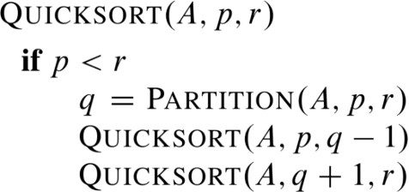

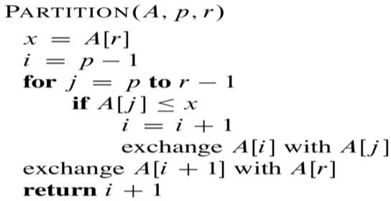

SELECTION SORT:

CODE:

OUTPUT:

QUICK SORT:

CODE:

OUTPUT:

ANALYSIS OF TIME COMPLEXITY:

SELECTION SORT:
QUICK SORT:

CONCLUSION: Implemented and analyzed Selection and Quick sort successfully.

EXPERIMENT NO. 2
LINKED LIST AND ITS OPERATIONS

AIM: Implementation of Singly Link List and various operations on it.

THEORY:
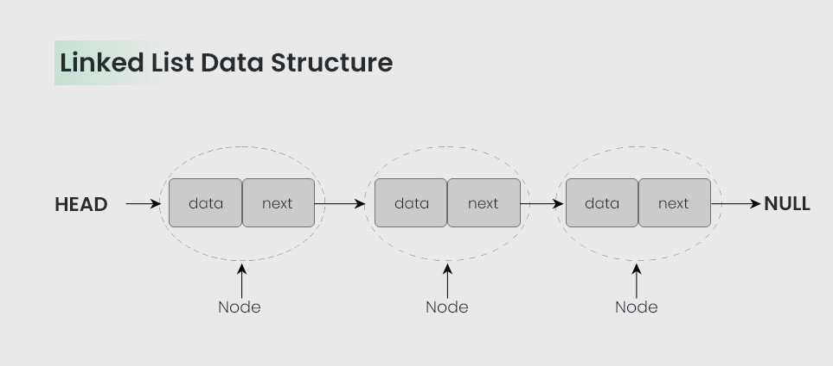
A linked list is a linear data structure that includes a series of connected nodes. Here, each node stores the data and the address of the next node. For example,

There are 3 different types of Linked Lists:

- Singly Linked List
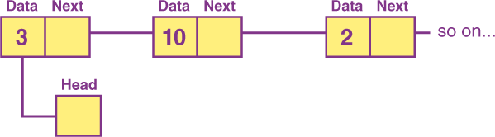

- Doubly Linked List
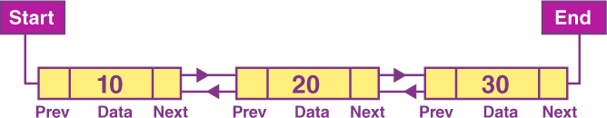

- Circular Linked List
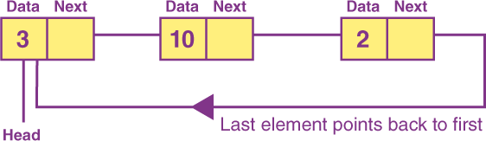

Basic Operations in Linked List
When it comes to linked lists, there are five operations supported by the series or list.

Traversal – Through this operation, we can access elements.
Insertion – In this operation, elements can be added at the starting of the list. Deletion – In this operation, elements can be deleted at the starting of the list.
Search – Through this operation, we can easily search for an element utilising the provided key.
Sort – Through this operation, we can sort the nodes of the linked list.

Operations on Singly Linked List
There are various operations which can be performed on singly linked list. A list of all such operations is given below.

Node Creation
struct node
{
int data;
struct node *next;
};
struct node *head, *ptr;
ptr = (struct node *)malloc(sizeof(struct node *));

Inserting Elements to a Linked List
A new node can be added to an existing linked list in the following cases.

- The new node is inserted at the beginning.
- The new node is inserted at the end.
- The new node is inserted after a given node.

Algorithm: Insert After An Element
Step 1: IF AVAIL = NULL
Write OVERFLOW Go to Step 12
[END OF IF]
Step 2: SET NEW_NODE = AVAIL Step 3: SET AVAIL = AVAIL -> NEXT
Step 4: SET NEW_NODE -> DATA = VAL Step 5: SET PTR = HEAD
Step 6: SET PREPTR = PTR
Step 7: Repeat Steps 8 and 9 while PREPTR -> DATA != NUM
Step 8:SET PREPTR = PTR
Step 9:SET PTR = PTR -> NEXT [END OF LOOP]
Step 10 : PREPTR -> NEXT = NEW_NODE Step 11: SET NEW_NODE -> NEXT = PTR Step 12: EXIT

Deleting Elements from a Linked List
A node can be deleted from a linked listed in the following cases.

- The first node is deleted.
- The last node is deleted.
- The node after a given node is deleted.

Algorithm: Delete from Beginning
Step 1: IF HEAD = NULL Write UNDERFLOW
Go to Step 5 [END OF IF]

Step 2: SET PTR = HEAD
Step 3: SET HEAD = HEAD -> NEXT Step 4: FREE PTR
Step 5: EXIT

Searching in Linked List

Finding an element is similar to a traversal operation. Instead of displaying data, we have to check whether the data matches with the item to find.

- Initialize PTR with the address of HEAD. Now the PTR points to the first node of the linked list.
- A while loop is executed which will compare data of every node with item.
- If item has been found, then control goes to last step.

Algorithm: Search
Step 1: [INITIALIZE] SET PTR = HEAD
Step 2: Repeat Steps 3 and 4 while PTR != NULL Step 3: If ITEM = PTR -> DATA
SET POS = PTR
Go To Step 5 ELSE
SET PTR = PTR -> NEXT [END OF IF]
[END OF LOOP] Step 4: SET POS = NULL Step 5: EXIT

CODE:

OUTPUT:

CONCLUSION: Implementation of the various operations of linked list successfully.

EXPERIMENT NO. 3
INFIX TO POSTFIX CONVERSION

AIM: Convert an expression from Infix to Postfix.

THEORY:

Infix expression
The expression of the form “a operator b” (a + b) i.e., when an operator is in-between every pair of operands.

Postfix expression
The expression of the form “a b operator” (ab+) i.e., When every pair of operands is followed by an operator.

Converting an Infix expression to a Postfix expression
To convert infix expression to postfix expression, use the stack data structure. Scan the infix expression from left to right. Whenever we get an operand, add it to the postfix expression and if we get an operator or parenthesis add it to the stack by maintaining their precedence.

Example:
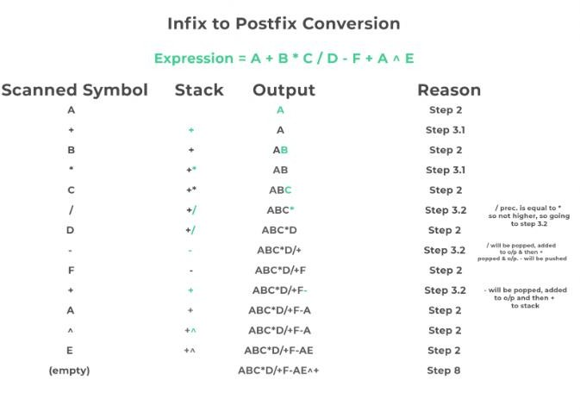

Algorithm:
- Scan the infix expression from left to right.
- If the scanned character is an operand, put it in the postfix expression.
- Otherwise, do the following
  - If the precedence of the current scanned operator is higher than the precedence of the operator on top of the stack, or if the stack is empty, or if the stack contains a ‘(‘, then push the current operator onto the stack.
  - Else, pop all operators from the stack that have precedence higher than or equal to that of the current operator. After that push the current operator onto the stack.
- If the scanned character is a ‘(‘, push it to the stack.
- If the scanned character is a ‘)’, pop the stack and output it until a ‘(‘ is encountered, and discard both the parenthesis.
- Repeat steps 2-5 until the infix expression is scanned.
- Once the scanning is over, Pop the stack and add the operators in the postfix expression until it is not empty.
- Finally, print the postfix expression.

CODE:

OUTPUT:

CONCLUSION: Successfully implemented the program for the conversion of infix to postfix conversion.

EXPERIMENT NO. 4

LINEAR QUEUE

AIM: Implementations of Linear Queue.

THEORY:

Queue is a linear data structure that follows a particular order in which the operations are performed for storing data. The order is First In First Out (FIFO). One can imagine a queue as a line of people waiting to receive something in sequential order which starts from the beginning of the line. It is an ordered list in which insertions are done at one end which is known as the rear and deletions are done from the other end known as the front. A good example of a queue is any queue of consumers for a resource where the consumer that came first is served first.
The difference between stack and queue is in removing an element. In a stack we remove the item that is most recently added while in a queue, we remove the item that is least recently added.
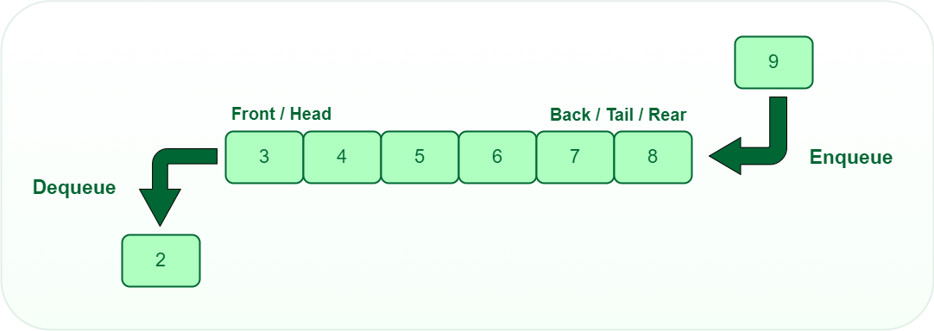

Basic Operations on Queue:
- enqueue(): Inserts an element at the end of the queue i.e. at the rear end.
- dequeue(): This operation removes and returns an element that is at the front end of the queue.

- front(): This operation returns the element at the front end without removing it.

- rear(): This operation returns the element at the rear end without removing it.
- isEmpty(): This operation indicates whether the queue is empty or not.
- isFull(): This operation indicates whether the queue is full or not.
- size(): This operation returns the size of the queue i.e. the total number of elements it contains.

Array implementation of Queue:
For implementing the queue, we only need to keep track of two variables: front and size. The front points to the first element in the queue, and size keeps track of the number of elements. When we enqueue an item, we insert it at the position front + size and then increment the size. For dequeuing, we check if the queue is empty and remove the item at the front. After removal, we shift all remaining elements to the left by one position. We then decrease the size to reflect the remova

Algorithm for enqueue:
- Check the queue is full or not
- If full, print “Queue is full” and exit.
- If the queue is not full
- Add the new element at the index front + size (this is the rear of the queue).
- Increment the size of the queue by 1 (i.e., size++).

Algorithm for dequeue:
- Check queue is empty or not
- If empty, print “Queue is empty” and exit
- If the queue is not empty:
- Print and return the front element (which is queue[front]).
- Shift all elements in the queue to the left by one position.
- Decrement the size by 1 (i.e., size--).

isFull Function
The isFull function will check whether the queue is full or not. As rear will always be pointing to the leftmost empty element, if the rear gets greater than or equal to the MAX_SIZE, it

means that it already contains the maximum possible number of elements.

Algorithm of isFull Function
Following is the algorithm for isFull Function:
- If rear == MAX_SIZE, return true.
- Else, return false.

isEmpty Function:
The isEmpty function will check whether the queue is empty or not. When we initialize a queue, we set the front = -1 and rear = 0. So we know that when there are no elements in the queue, the front = rear - 1.

Algorithm of isEmpty Function
  - Following is the algorithm for isFull Function:
  - If front == rear - 1, return true.
  - Else, return false

CODE:

OUTPUT:

CONCLUSION: Thus we have successfully implemented Linear queue and different operations on it.

EXPERIMENT NO. 5

BINARY TREE TRAVERSAL

AIM: Implementation of different Tree Traversal techniques.

THEORY:
Tree Traversal refers to the process of visiting or accessing each node of the tree exactly once in a certain order. Tree traversal algorithms help us to visit and process all the nodes of the tree. Since tree is not a linear data structure, there are multiple nodes which we can visit after visiting a certain node. There are multiple tree traversal techniques which decide the order in which the nodes of the tree are to be visited.

A Tree Data Structure can be traversed in following ways:
- Inorder Traversal
- Preorder Traversal
- Postorder Traversal

Example
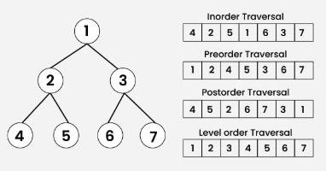

Algorithm for Inorder Traversal:
- Inorder(tree)
Inorder traversal visits the node in the order: Left -> Root -> Right
  - Traverse the left subtree, i.e., call Inorder(left->subtree)
  - Visit the root.
  - Traverse the right subtree, i.e., call Inorder(right->subtree)

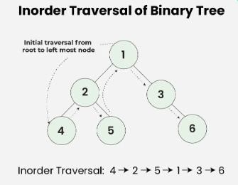

Preorder traversal:
visits the node in the order: Root -> Left -> Right
  - Visit the root.
  - Traverse the left subtree, i.e., call Preorder(left->subtree)
  - Traverse the right subtree, i.e., call Preorder(right->subtree)
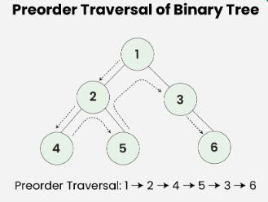

Postorder traversal
visits the node in the order: Left -> Right -> Root
  - Traverse the left subtree, i.e., call Postorder(left->subtree)
  - Traverse the right subtree, i.e., call Postorder(right->subtree)
  - Visit the root.

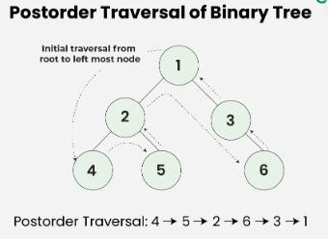

CODE:

OUTPUT:

CONCLUSION: Thus, we have successfully implemented different tree traversal techniques.

EXPERIMENT NO. 6

SEARCHING AND SORTING

AIM: Implementation of Linear Search, Binary Search and Bubble Sort.

THEORY:

Linear Search

Linear Search is the process of finding some particular element in the list. If the element is present in the list, then the process is called successful, and the process returns the location of that element; otherwise, the search is called unsuccessful. Linear search is also called as sequential search algorithm. In Linear search, we simply traverse the list completely and match each element of the list with the item whose location is to be found. If the match is found, then the location of the item is returned; otherwise, the algorithm returns NULL. It is widely used to search an element from the unordered list. The worst- case time complexity of linear search is O(n).

Binary Search
A binary search algorithm is a technique for finding a particular value in a linear array, by ruling out half of the data at each step, widely but not exclusively used in computer science. A binary search finds the median, makes a comparison to determine whether the desired value comes before or after it, and then searches the remaining half in the same manner. Another explanation would be: Search a sorted array by repeatedly dividing the search interval in half Begin with an interval covering the whole array. If the value of the search key is less than the item in the middle of the interval, narrow the interval to the lower half Otherwise, narrow it to the upper half.

Bubble Sort
Bubble sort is a sorting algorithm that compares two adjacent elements and swaps them until they are in the intended order. This sorting algorithm is comparison-based algorithm in which each pair of adjacent elements is compared and the elements are swapped if they are not in order. This algorithm is not suitable for large data sets as its average and worst case complexity are of O(n²) where n is the number of items.

ALGORITHM:

Linear Search

// 'a' is the given array, 'n' is the size of given array, 'val' is the value to search
- set pos = -1
- set i = 1
- repeat step 4 while i <= n
- if a[i] == val
set pos = i print pos go to step 6
set ii = i + 1
- if pos = -1
print "value is not present in the array "
- exit

Binary Search

- Sort an array a[j] in increasing order.
- Read ‘n’ elements in the array , say ‘a ’.
- Read the element to be searched, say ‘KEY ‘.
- low = 0 , high = n-1
- while(high>=low) perform following steps. Find the middle element.
- mid = (low + high )/ 2
- if ( KEY= a[mid] )
print (‘ element found at mid position)
- if KEY < a[mid] then search for target in a[low] to a[mid-l] else search for target in a[mid+l] to a[high].
- if (KEY < a[Mid_position]) high = mid_position - 1;
else
low = mid_position + 1;
- Stop.

Bubble Sort
// A is an array
for i ← 1 to length [A] do
for j ← length [A] down-to i +1 do if A[j] < A[j-1] then
Exchange A[j] ⟷ A[j-1]

CODE:

OUTPUT:

ANALYSIS OF TIME COMPLEXITY:
Linear Search: O(n) Binary Search: O( log n ) Bubble Sorting: O(n²)

CONCLUSION: Thus we have successfully implemented linear and binary searching techniques and bubble sorting.

EXPERIMENT NO. 7

HASHING

AIM: Implementation of Hashing techniques.

THEORY:
A hash table is a data structure used to implement an associative array, a structure that can map keys to values. A hash table uses a hash function to compute an index into an array of buckets or slots. A hash table is a data structure which is used to store key-value pairs. Hash function is used by hash table to compute an index into an array in which an element will be inserted or searched.
Linear probing is a collision resolving technique in Open Addressed Hash tables. In this method, each cell of a hash table stores a single key–value pair. If a collision is occurred by mapping a new key to a cell of the hash table that is already occupied by another key. This method searches the table for the following closest free location and inserts the new key there.

Example: In linear probing, we linearly probe for next slot. For example, the typical gap between two probes is 1 as seen in the example below.

Let hash(x) be the slot index computed using a hash function and S be the table size
If slot hash(x) % S is full, then we try (hash(x) + 1) % S
If (hash(x) + 1) % S is also full, then we try (hash(x) + 2) % S If (hash(x) + 2) % S is also full, then we try (hash(x) + 3) % S

Let us consider a simple hash function as “key mod 7” and a sequence of keys as 50, 700, 76, 85, 92, 73, 101.

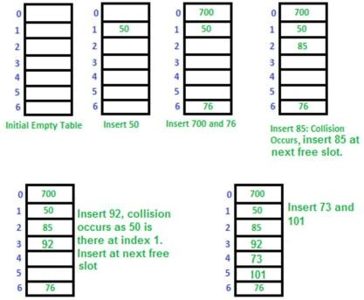

EXAMPLE:
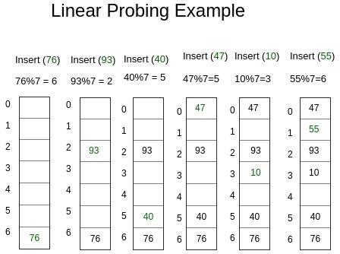

ALGORITHM
- Algorithm for inserting element in array using linear probing Hashtable is an array of size TABLE_SIZE
Step 1: Read the value to be inserted, key Step 2: let i = 0
Step 3: hkey = key% TABLE_SIZE
Step 4: compute the index at which the key has to be inserted in hash table index = (hkey + i) % TABLE_SIZE
Step 5: if there is no element at that index then insert the value at index and STOP Step 6: If there is already an element at that index
step 4.1: i = i+1
step 7: if i < TABLE_SIZE then go to step 4

- Algorithm for Searching element in array using linear probing Hashtable is an array of size
= TABLE_SIZE
Step 1: Read the value to be searched, key 39 Step 2: let i = 0
Step 3: hkey = key% TABLE_SIZE
Step 4: compute the index at which the key can be found index = (hkey+ i) % TABLE_SIZE
Step 5: if the element at that index is same as the search value, then print element found and STOP
Step 6: else
step 4.1: i = i+1
Step 7: if i < TABLE_SIZE then go to step 4

CODE:

OUTPUT:

CONCLUSION: Learnt the implementation of linear probing used for indexing values in hash tables for efficient storage.

EXPERIMENT NO. 8

LINKED LIST
Aim: Perform merging of two sorted Linked Lists using LeetCode platform.

Explanation:
The heads of two sorted linked lists list1 and list2 are given. Merge the two lists into one sorted list. The list should be made by splicing together the nodes of the first two lists. Return the head of the merged linked list.

Example 1:
Input: list1 = [1, 2, 4], list2 = [1, 3, 4]
Output: [1, 1, 2, 3, 4, 4]

Example 2:
Input: list1 = [], list2 = [] Output: []

Example 3:
Input: list1 = [], list2 = [0] Output: [0]

Constraints:
The number of nodes in both lists is in the range [0, 50].
-100 <= Node.val <= 100
Both list1 and list2 are sorted in non-decreasing order.

CODE:

OUTPUT:

CONCLUSION: Performed merging of two sorted Linked Lists using LeetCode platform successfully.

EXPERIMENT NO. 9

STACK

Aim: Validate the correctness of parenthesis using LeetCode platform. Given a string ‘s’ containing just the characters '(', ')', '{', '}', '[' and ']', determine if the input string is valid.

Explanation:
An input string is valid if:
- Open brackets must be closed by the same type of brackets.
- Open brackets must be closed in the correct order.
- Every close bracket has a corresponding open bracket of the same type.

Example 1:
Input: s = "()" Output: true

Example 2:
Input: s = "()[]{}" Output: true

Example 3:
Input: s = "(]" Output: false

Example 4:
Input: s = "([])" Output: true

Constraints:
1 <= s.length <= 104
s consists of parentheses only '()[]{}'.

CODE:

OUTPUT:

CONCLUSION: Correctness of parenthesis is performed using LeetCode platform successfully.

EXPERIMENT NO. 10

CIRCULAR QUEUE

Aim: Find the Winner of the Circular Game using Queue using LeetCode platform. There are n friends that are playing a game. The friends are sitting in a circle and are numbered from 1 to n in clockwise order. More formally, moving clockwise from the ith friend brings you to the (i+1)th friend for 1 <= i < n, and moving clockwise from the nth friend brings you to the 1st friend. Find the Winner of the Circular Game.

Explanation:
The rules of the game are as follows:
- Start at the 1st friend.
- Count the next k friends in the clockwise direction including the friend you started at. The counting wraps around the circle and may count some friends more than once.
- The last friend you counted leaves the circle and loses the game.
- If there is still more than one friend in the circle, go back to step 2 starting from the friend immediately clockwise of the friend who just lost and repeat.
- Else, the last friend in the circle wins the game.
Given the number of friends, n, and an integer k, return the winner of the game.

Input: n = 5, k = 2 Output: 3
Explanation: Here are the steps of the game:
- Start at friend 1.
- Count 2 friends clockwise, which are friends 1 and 2.
- Friend 2 leaves the circle. Next start is friend 3.
- Count 2 friends clockwise, which are friends 3 and 4.
- Friend 4 leaves the circle. Next start is friend 5.
- Count 2 friends clockwise, which are friends 5 and 1.
- Friend 1 leaves the circle. Next start is friend 3.

- Count 2 friends clockwise, which are friends 3 and 5.
- Friend 5 leaves the circle. Only friend 3 is left, so they are the winner.

Example 2:
Input: n = 6, k = 5 Output: 1 Explanation:
The friends leave in this order: 5, 4, 6, 2, 3. The winner is friend 1.

Constraints:
1 <= k <= n <= 500

CODE:

OUTPUT:

CONCLUSION: Game based on queue is implemented using LeetCode platform successfully.

